**TASK REPORT**

**ALGORITHMS AND DATA STRUCTURE**

**WEEK 3**

**Created by:**

**Onic Agustino**

**L200234275**

**X**

**INFORMATICS ENGINEERING**

**FACULTY OF COMMUNICATION AND INFORMATICS**

**UNIVERSITAS MUHAMMADIYAH SURAKARTA**

**2024/2025**

**TASK**

1. **Exercise 1**

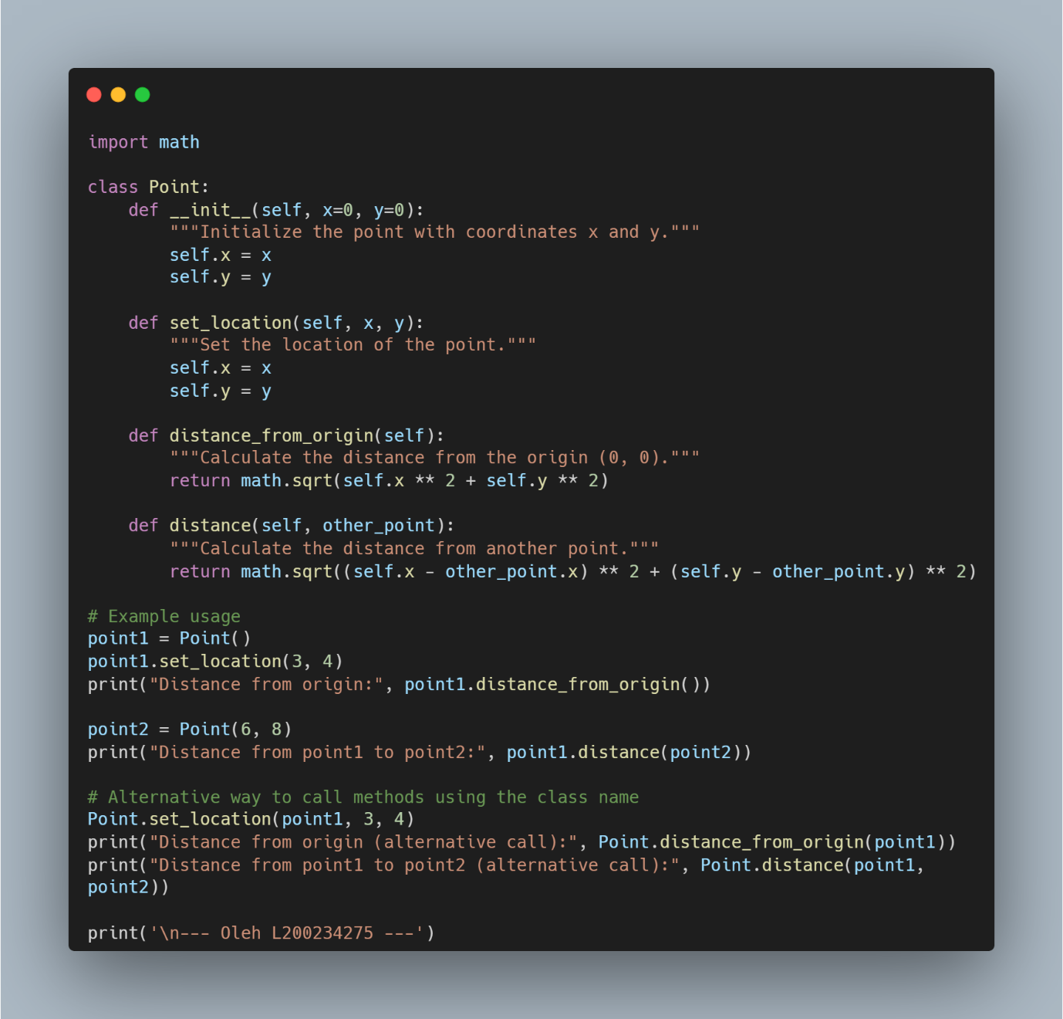

Picture 1.1 the code.

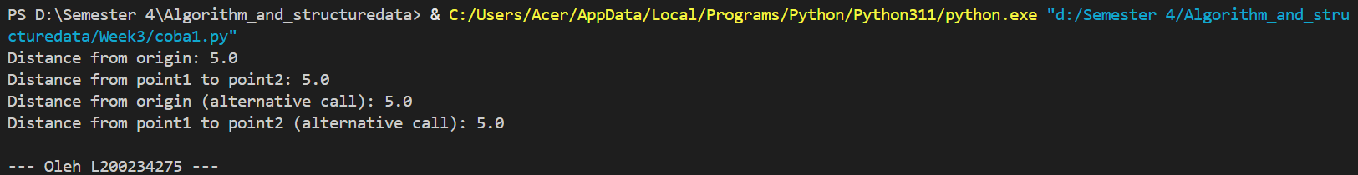

Picture 1.2 the output.

1. **Exercise 2**

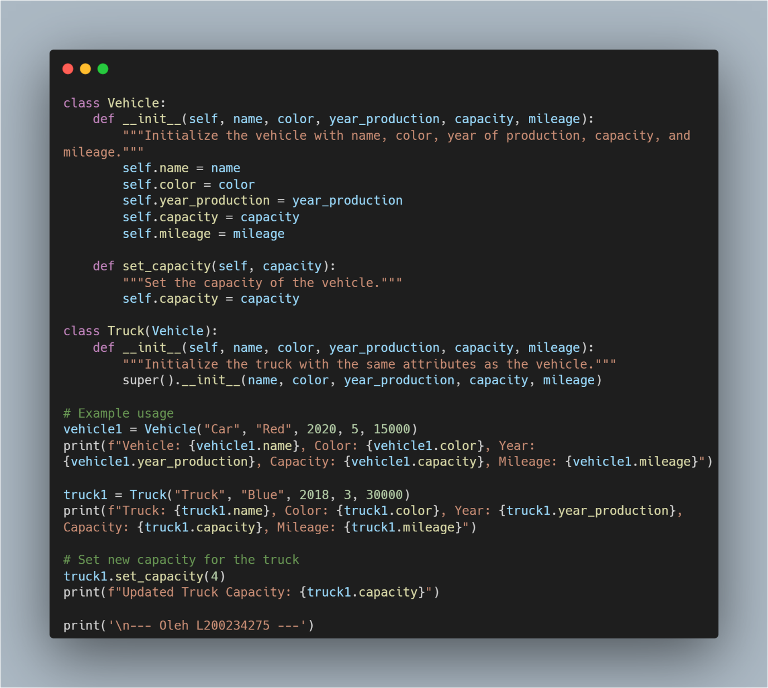

Picture 2.1 the code.

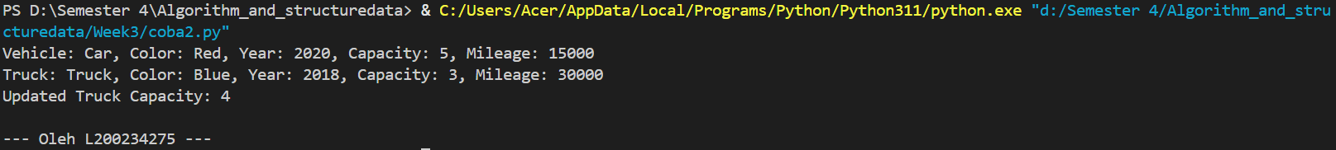

Picture 2.2 the output.